**Laboratorio #2 de TEA**

**Lab02-cadena**

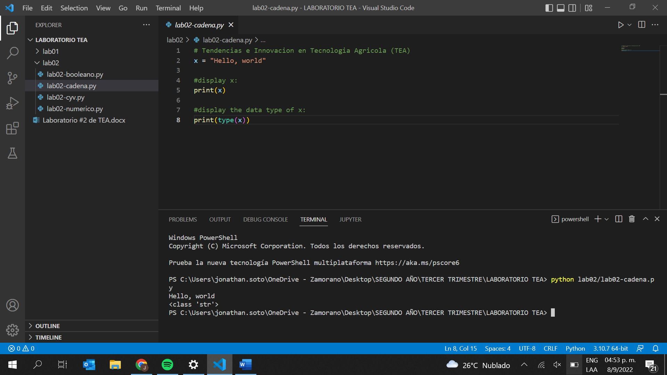

**Lab02-numerico**

**Lab02-booleano**

**Lab02-cyv**

